|  |  |
| --- | --- |
|  | **DEPARTMENT OF COMPUTER SYSTEMS ENGINEERING**  **MEHRAN UNIVERSITY OF ENGINEERING & TECHNOLOGY, JAMSHORO**  **Database Management Systems (4th Semester) 18CS**  **Lab Experiment 10** |

|  |  |  |  |
| --- | --- | --- | --- |
| **Roll No:** |  | **Date of Conduct:** |  |
| **Submission Date:** |  | **Grade Obtained:** |  |

|  |  |  |  |
| --- | --- | --- | --- |
| **Problem Recognition (0.3)** | **Completeness & accuracy (0.4)** | **Timeliness (0.3)** | **Score (1.0)** |
|  |  |  |  |

**Objective: Creating database users and controlling user access.**

**Tools: MySQL/Oracle.**

**Introduction:**

**Create a New User**

MySQL has a CREATE USER statement that lets you create a new user on your database. If you're working with a new database, you might only have a root user set up. To create users, you first need to log in with the root user or another user account that has permissions to create users.



At this point *newuser* has no permissions to do anything with the databases. In fact, even if *newuser* tries to login (with the password, *password*), they will not be able to reach the MySQL shell.

Therefore, the first thing to do is to provide the user with access to the information they will need.



**How to Grant Different User Permissions**

There are numerous table and column level privileges that you can grant. You can also grant users the privileges to create other users or revoke other user privileges. The permissions you grant to a user should depend on what level of access you think they should have. The rule for security permissions is to give a user the least amount of privileges they need to accomplish normal tasks. For instance, you shouldn't grant all permissions to a standard user when they only need to run SELECT statements on a Customer table.

Here is a short list of other common possible permissions:

* ALL PRIVILEGES- as we saw previously, this would allow a MySQL user full access to a designated database (or if no database is selected, global access across the system)
* CREATE- allows them to create new tables or databases
* DROP- allows them to them to delete tables or databases
* DELETE- allows them to delete rows from tables
* INSERT- allows them to insert rows into tables
* SELECT- allows them to use the SELECT command to read through databases
* UPDATE- allow them to update table rows
* GRANT OPTION- allows them to grant or remove other users’ privilege

This practical is an overview of managing user accounts and passwords. Keeping track of users and their permissions greatly reduces the chance that your database goes hacked without notice. By managing users, you keep granular control over your data and protect it from unauthorized access.

**Lab Task**

**1. For a book library, create 3 users with names books_admin, books_accountant, books_user and assign passwords of your own choice.**

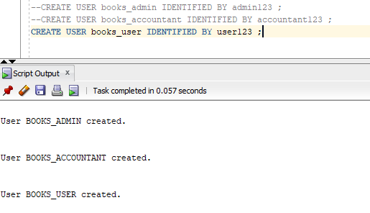**Task:**

**2. Assign DBA, RESOURCE and CONNECT roles to books_admin, books_accountant, books_user, respectively.**

**Task:**

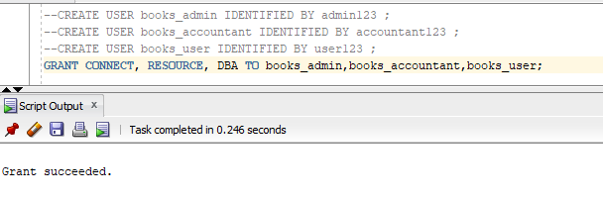

**3. Assign select, update, delete, and insert object privileges on books table to books_admin and books_accountant users.**

**Task:**

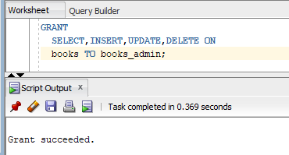

**4. Assign select object privilege on books table to books_user user.**

**Task:**

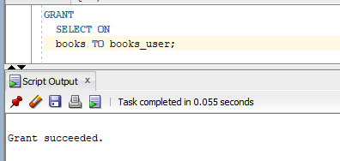

**5. Change the password of user books_accountant.**

**Task:**

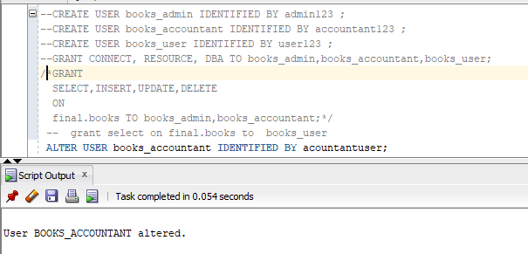

**6. Revoke the assigned object privilege from books_user.**

**Task:**

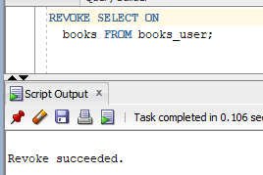

**7. What privilege should a user be given to log into the oracle server? Is this a system or object privilege?**

**Answer:** The CREATE SESSION system privilege.

**8. What privilege should a user be given to create tables and views?**

**Answer:** The CREATE TABLE privilege.

**9. If you create a table, who can pass along privileges to other users on your table?**

**Answer:** You can, or anyone you have given those privileges to by using the WITH GRANT OPTION.

**10. You are the DBA. You are creating many users who require the same system privileges. What would you use to make your job easier?**

**Answer:** Create a role containing the system privileges and grant the role to the users.